Ques 1. A cylindrical bar is 20mm diameter and 1000 mm long. During a tensile test it is found that the longitudinal strain in 4 times the lateral strain. Calculate the modulus of rigidity(C) and the bulk modulus, if its elastic modulus is 1x105 N/mm² . Find the change in volume when the bar is subjected to a hydrostatic pressure of 100 N/mm2
Solution: d=20mm;
l=1000mm
Longitudinal strain = 4 times lateral strain
E = 1x105 N/mm² , p = 100 N/mm2
Rigidity modulus C=?
Bulk modulus K=?
δV = ?
Poisson’s ratio = μ = 𝑙𝑎𝑡𝑒𝑟𝑎𝑙 𝑠𝑡𝑟𝑎𝑖𝑛 𝑙𝑜𝑛𝑔𝑖𝑡𝑢𝑑𝑖𝑛𝑎𝑙 𝑠𝑡𝑟𝑎𝑖𝑛 = 1/4 = 0.25
E = 2C (1+ μ)
C = E/2(1+ μ)
= 1*10⁵ / (2*(1+0.25))
= 4 ∗ 10⁴ 𝑁/𝑚𝑚2
E = 3K (1-2 μ)
K = E/ 3 (1-2 μ)
= 1∗10⁵ / (3*( 1−2∗0.25)) = 2/3 ∗ 10⁵ 𝑁/𝑚𝑚2
Volumetric strain = 𝑒𝑣 = 𝑝/𝐾 = 100/(2/3 ∗10⁵) = 1.5 x 10⁻³
Decrease in volume = 𝑒𝑣 𝑉 = 1.5 x 10⁻³ x (π/4) x 20² x 1000 mm³ = 471mm³

Ques 2. A 50mm cube is subjected to uniform stress of $σ$_{x}=200Mpa. When the change in dimension between two parallel faces in the direction of stress in 0.025mm. determine the change in the volume of the cube. Poisson’s ratio (µ)=0.25
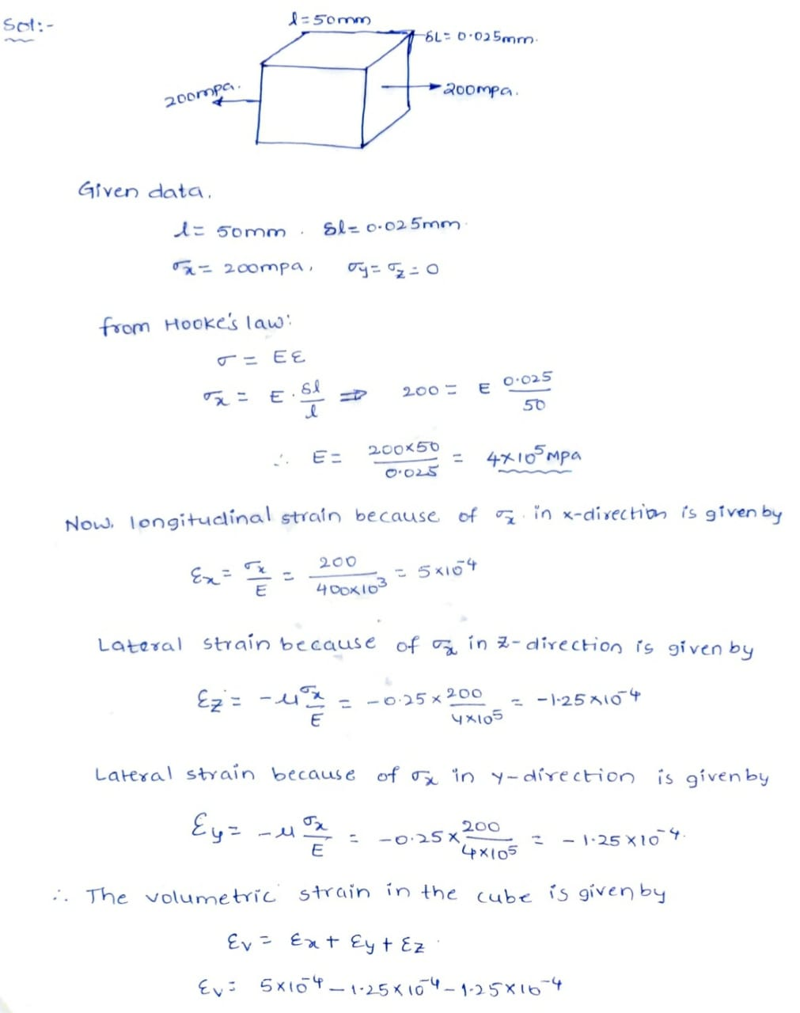
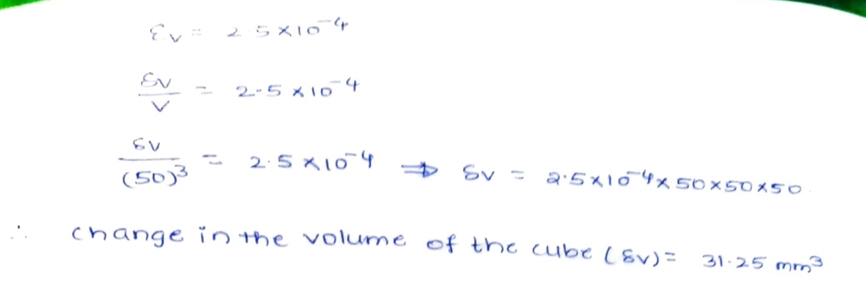

Ques 3. Do you think that a plane stress system give rise to a plane strain system always? Give reasons for your answer. Three principal stresses $σ$₁₁, $σ$₂₂$,σ$₃₃ are acting on the three faces of a cube respectively. Express the resulting three principal strains in terms of the principal stresses.
